**Simple Instruction Manual for JavaScript for displaying photos of virtual 3d object**

You can see 3d.html in my sending files.

First of all, reference jQuery, page.js and Spritespin scripts.

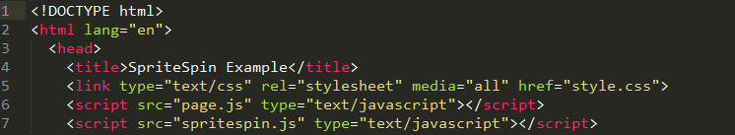

Second, create a container for SpriteSpin.



And then, initialize the plugin.

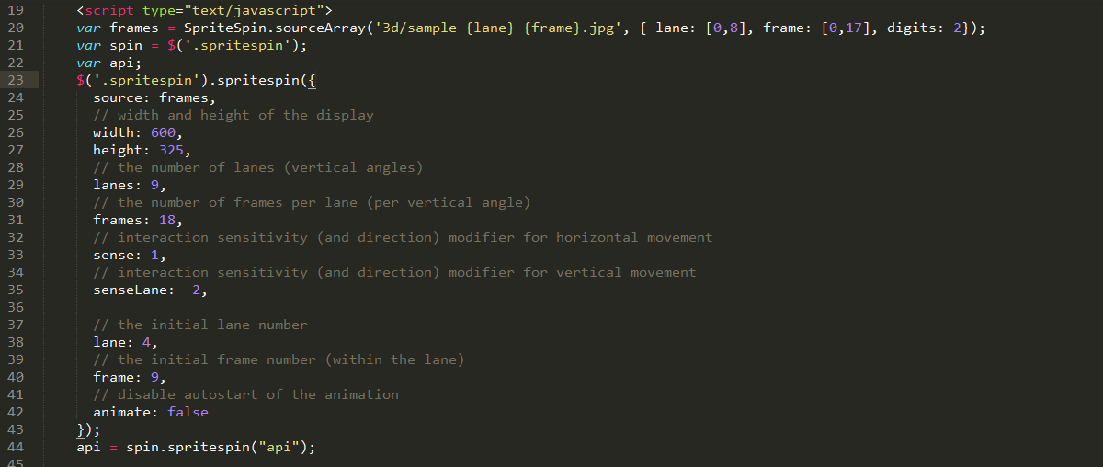

You can see the kinds of jpg name and folder name in the above figure.

As following jpg name,

*Sample-{lane}-{frame}.jpg*

*Lane – the number of rows*

*Frame – the number of images per row*

You must change the jpg name as this file’s needs or maybe change as your requirements.

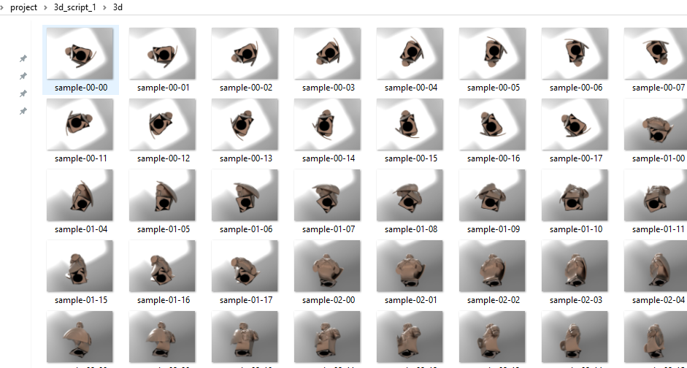

And you must type the number of rows and images per row.

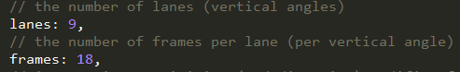

At last, the keyboard control was finished by using spritespin api and keydown javascript function.

